

**Student ID/ 21634138.**

**Name/ Shalaby, Marwa Fawzy.**

**Biogenic Marine Sediments Rocks**

**Abstract**

When the geologist studies the fragments, she notes that the composition of fragments changes with depth. At some depths, fragments consist of grains of sand cemented together, or of tightly packed clay that is harder than pottery. At other depths, they consist of broken shell aggregates or of crystalline salt masses. The geologist has observed the transition of loose sediment into solid layers of sedimentary rock as burial depth progressively increases. Geologists divide sedimentary rocks into four major classes, based on their mode of origin: Clastic sedimentary rock, Biochemical sedimentary rock, chemical sedimentary rock, organic sedimentary rock. The sediments deposited in the ocean are an archive of historical information about the Earth and, specifically, they provide information about global biogeochemical cycles. The distribution of sediments in the ocean is determined by biological and chemical processes and therefore should be discussed in the context of marine chemistry also The most important biogenic minerals are carbonates and biogenic silica (opal) Carbonate Sediments are composed principally of skeletal remains of calcite or aragonite secreting organisms. The abundance and distribution of sediments on the oceans depends on the Amount of material delivered to the seafloor,, The preservation of the sedimentary components, the degree of dilution by other components. CaCO3 is the main mineral in marine sediments. About ¼ of the ocean basins contains sediment that is >30 % CaCO3 (mostly calcite). In addition, CaCO3 production, burial, and dissolution effects ocean alkalinity so a fundamental difference between carbonate and silicate sediments is that seawater is everywhere under-saturated with respect to silica (silica secreting organisms have to spend energy to metabolize and produce the shells).

**Introduction**

On an isolated, windswept drilling platform in the North Sea off the coast of Scotland, a group of roughnecks ready a multimillion- dollar drilling rig—their plan is to penetrate the sea floor and see what layers lie beneath. The North Sea formed as a consequence of rifting that began tens of millions of years ago. During rifting, what was once dry land between Great Britain and continental Europe slowly sank or, in geologic parlance, “subsided.” Rivers carried gravel, sand, and clay from the surrounding land into the newborn North Sea, and these sediments collected in layers. At certain stages in the process, salts precipitated from seawater and the shells of sea creatures settled and collected on the sea floor. As the drilling begins, a geologist stationed on the deck of the platform examines the material that has been flushed out of the lengthening drill hole. At first, drilling brings up soft mud and loose sand, silt, pebbles, and shell fragments. But as the hole goes deeper, the material coming up holds together in soft but coherent clumps. Eventually when the hole has entered layers that now lie almost a kilometer below the sea floor, the drilling fluid flushes out chips and chunks of solid rock. When the geologist studies these fragments, she notes that the composition of fragments changes with depth. At some depths, fragments consist of grains of sand cemented together, or of tightly packed clay that is harder than pottery. At other depths, they consist of broken shell aggregates or of crystalline salt masses. The geologist has observed the transition of loose sediment into solid layers of sedimentary rock as burial depth progressively increases.

**Classes of Sedimentary Rocks**

Geologists divide sedimentary rocks into four major classes, based on their mode of origin:

1. Clastic sedimentary rock

Consists of cemented-together clasts, solid fragments and grains broken off of preexisting rocks (the word comes from the Greek *klastos*, meaning broken).

1. Biochemical sedimentary rock

Consists of shells.

1. Organic sedimentary rock

Consists of carbon-rich relicts of plants or other organisms;

(4) Chemical sedimentary rock

Is made up of minerals that precipitated directly from water solutions.

**Marine sedimentary rocks:**

The sediments deposited in the ocean are an archive of historical information about the Earth and, specifically, they provide information about global biogeochemical cycles. The distribution of sediments in the ocean is determined by biological and chemical processes and therefore should be discussed in the context of marine chemistry. The first detailed study of marine sediments was done in the 1870’s. An expedition called the “Challenger expedition” led by Sir Murray and Renard dredged the bottom of the ocean systematically and described the sediments. They classified their findings into 5 major groups: red clays, carbonate ooze, silicic ooze, nodules and volcanic material. This is quite similar to what we do today. We categorize the type of sediments mostly by their source and composition. In the late 1940’s, the first recovery of a long core was achieved and that introduced the possibility of investigating sediments over time. Shortly afterward, a global ocean drilling program was designed and sediment cores are now continuously collected from different oceanic locations. The sediments in the ocean consist of 3 major components: detrital, biogenic and authigenic based on their origin. They are classified using the 30% rule, if there is more than 30% of any type of component in the sediment it will be classified as such. However, it must be kept in mind that there are no pure detrital, authigenic or biogenic sediments; sediments are always mixtures of different components

**Detrital:** brought into the ocean from outside, consists of terrigenous, volcanic, and cosmogenic material

**Authigenic** components are oceanic inorganic minerals that precipitate directly from the seawater, either in the water column or in the sediment after burial. These minerals make up only a small fraction of deep-sea sediments today, but in special environments and certain geological times, they comprise the bulk of the sedimentary sequence.

**Biogenic Sediments** are one of the most important constituents of marine sediments. As the name implies, these form directly or indirectly through biological activity. They are made of a variety of delicate and intricate structures mostly of skeletal remains of marine phytoplankton and zooplankton. The life span of most of these organisms is on the order of weeks, so there is a slow continuous “rain” of their remains down through the water column to build successive layers of sediment. The distribution of these sediments would depend on the abundance of organisms precipitating these phases and dissolution at depth (e.g. preseration).

**Biogenic Sediments:**

The most important biogenic minerals are carbonates and biogenic silica (opal) Carbonate Sediments are composed principally of skeletal remains of calcite or aragonite secreting organisms. Coccolithophores are phytoplankton covered with a test made of plates of calcite, 10m in size that are called coccoliths; the organisms shed these plates throughout their life time. An organic membrane covers the coccoliths and this inhibits their dissolution. The coccoliths are also referred to as “nano fossils”; nano means dwarf in Greek. Coccolithophores are abundant in central gyres where productivity is relatively low.

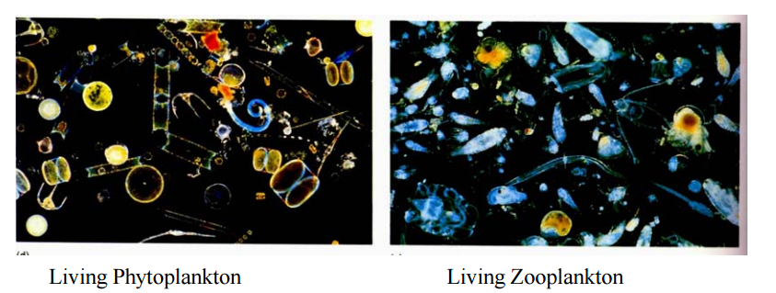

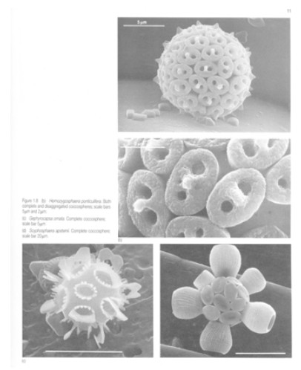

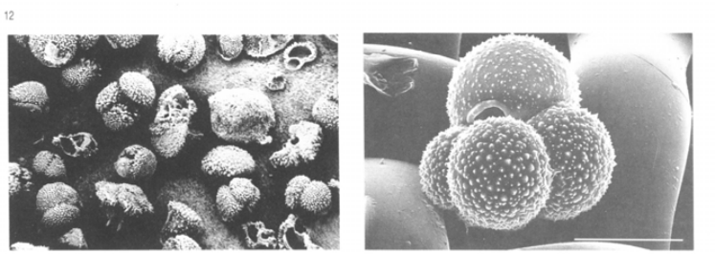**Foraminifera** are protists that produce calcite exoskeletons, or tests. They can be planktonic (float on the surface) or benthic (live at the bottom) and range in size from 30 m to 1mm. The spiny ones have symbionts and live in the photic zone where light is available; these spiny species are very delicate and more soluble. Non-spiny forms are better preserved in sediments.

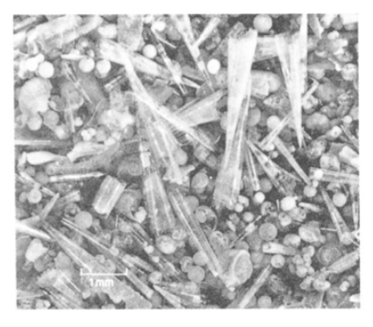 **Pteropods** are planktonic gastropods, mollusks that are restricted to the tropics and subtropics and have aragonitic shells. Usually not preserved well and cannot be found in sediments deeper than ~2000m.

Corals are colonial organisms that form aragonitic reef structures that are common in shallow coastal environments of the tropics. As they grow concentric layers, they provide a vast array of information – in particular for the short-term high resolution SST, sea level changes, precipitation, run off, upwelling and more. Some other carbonate secreting organisms include alga, mollusks, and echinoderms.

**Silica Secreting Organisms include:**

Diatoms which are unicellular alga a few micron to 200 micron in size. They secrete frustules from amorphous hydrated silica (opal). They are abundant in high productivity areas such as coastal upwelling, equatorial regions and high latitude areas. There are some benthic diatoms that are restricted to shallow waters. **Radiolarians** are large zooplankton in the range of 50- 300 micron. They secrete very intricate shells structures. They are usually abundant in low latitudes. Sponges and silicoflagellates also leave siliceous remains, but are less common today. 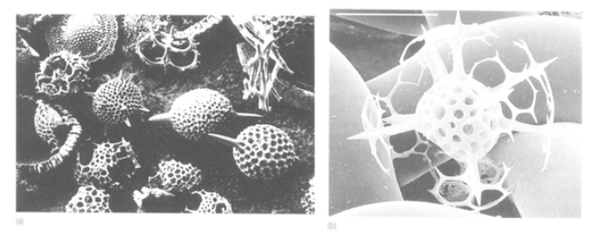

Other biogenic minerals include apatite, which is a phosphatic mineral that mostly makes the bones and teeth of fish and marine mammals. Celestite is an SrSO4 mineral that forms the shells of acantharian zooplanktons that are quite abundant, but their shells are so soluble and are not preserved in most sediments. Barite is another biogenic mineral that, although does not form directly within organisms, it is precipitated when organic matter or the soft tissue of organisms decompose; this enriches the closed environment with Ba and SO4 thus, promoting barite saturation and precipitation.

Although not a mineral, organic matter is an important component of sediments. There are a lot of organisms that do not form hard parts and what is preserved from them is the organic matter. On average in the ocean only about 1% of the organic matter that sinks to the bottom of the ocean is preserved. The amount of organic matter preserved in the sediment depends on how much is produced and the preservation efficiency.

**Sedimentary Organic Carbon Preservation**

There are several controls that affect the org C distribution in in sediments. Accumulation in sediments depends on:

Flux of org C from surface (productivity), water depth, and sedimentation rate

1. Overlying productivity High prod High org C

2. Water depth Deep Lower org C

3. Sedimentation rate High sed rate High org C

Some people think that **Surface area** of the particle is important in controlling preservation. This is based on empirical correlations between surface area and % organic C. The “loading” of OC onto mineral surfaces is typically ~0.5-1.0 mgOC/m2, which has been referred to as “monolayer equivalent” because it corresponds to ~one molecule deep, full-coverage of the mineral surface with a protein-like molecule. The organic component associated with the organic C monolayer is highly resistant to degradation.

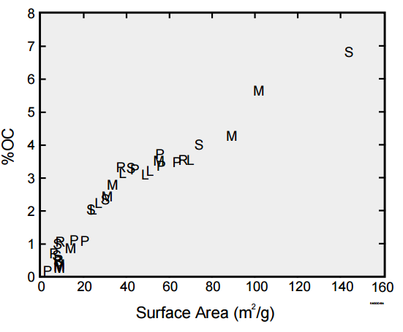

Laboratory experiments subjecting organic matter desorbed from “old” marine sediments to seawater found that this organic matter is extensively re-mineralized within a week, indicating the sorbed organic matter is protected by its "environment” and not by an intrinsically un-reactive chemical structure.

Previous theories on the processes that control organic matter preservation were all based on correlations of organic C to productivity, sedimentation rate, O2 content and organic matter source. The idea was that OM preservation heavily depends on oxygen content. This hypothesis is based more on an attempt to understand the mechanism involved in organic C preservation rather than simply correlative information. However, this does not seem to hold in many places. There are multiple parameters controlling organic C preservation, including the exposure time to oxygen.

**The abundance and distribution of sediments on the oceans** depends on the

(a) **Amount of material delivered** to the seafloor, which in turn depends on proximity to the source (for terrigenous and hydrothermal sediments) and the abundance and distribution of the organism forming the mineral (for biogenic minerals).

(b) Because the type of sediment is defined in a relative manner the degree of **dilution** by other components is important; although productivity is very high in coastal environments, there is so much river deposition that the sediment is classified as terrigenous.

(c) **The preservation** of the sedimentary components is a major issue. This is a function of the solubility of the minerals and the chemistry of the ocean. Some of the deep sea is supersaturated with respect to the minerals that form the tests and some is under-saturated. Thus, ocean chemistry plays an important role in the preservation of certain minerals in marine sediments.

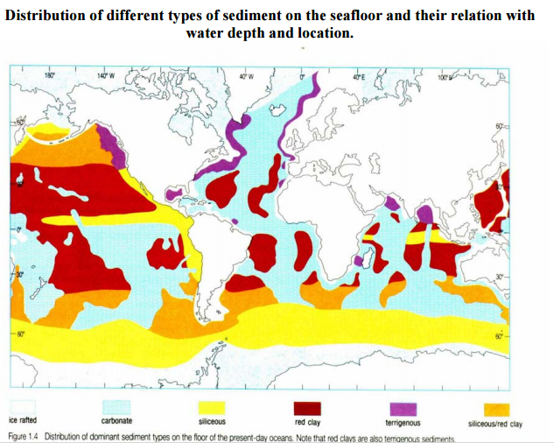

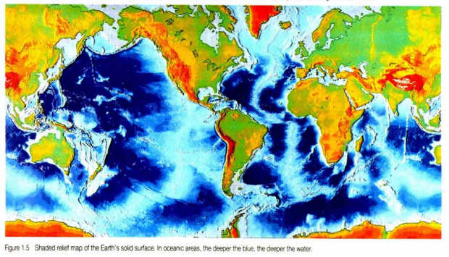

**Carbonate Distribution and Preservation in the Ocean**

CaCO3 is the main mineral in marine sediments. About ¼ of the ocean basins contains sediment that is >30 % CaCO3 (mostly calcite). In addition, CaCO3 production, burial, and dissolution effects ocean alkalinity. About 20 % of the particulate CaCO3 rain is buried, and the percent burial depends on seawater chemistry. Variations in the concentration of CaCO3 in sediments over time reveal changing ocean chemistry.

There are two mineralogical forms of calcium carbonate that have very different solubility:

Aragonite – hexagonal crystallographic structure

Calcite – rhombihedral crystallographic structure

Aragonite is deposited in shallow water as coral and coraline algae; calcite is deposited mostly in the deep ocean as tests of microscopic algae that grow in surface waters. Milliman and Droxler estimate that roughly half of the CaCO3 presently being deposited in the ocean is in coral reefs and coraline algae and half in deep-sea sediments, however the estimates vary quite a bit. There is a very clear depth dependence of the CaCO3 content of marine sediments. If water were removed from the ocean, the ocean floor would look like snow-capped mountains. The “snow line”, the level below which there is no calcium carbonate preserved in the sediment is called the **Calcite Compensation Depth (CCD).** At the CCD, the rate of CaCO3 input equals the rate of dissolution. Below the CCD is where the red/brown clay (and in places, silica) accumulates.

The CCD is kinetically controlled. Carbonate dissolution begins at shallower depths than the CCD. It is difficult to define the depth where dissolution begins because of the nonlinear relationship between weight % calcite and the amount of the rain that has dissolved. Imagine a situation where 90 calcite tests and 10 clay mineral grains of equal weight fall to every square cm of sediment surface. If nothing dissolves, the weight percent CaCO3 is 90 %. If 20 % (18 tests) dissolve, the sediment has now 90-18= 72 tests, and 72 / (72 + 10) = 0.87 or 87 % CaCO3. If half dissolves (45 tests left), it is, 45 / (45 + 10) = 0.82, 82 % CaCO3. Weight percent is very insensitive to the 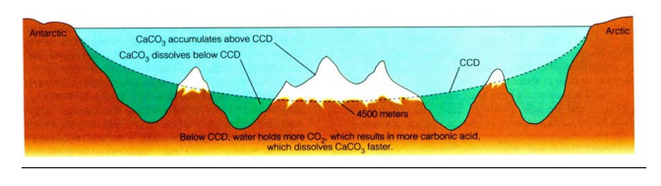amount of dissolved material.

The depth where dissolution starts can be determined by

(a) Thermodynamic calculations of solubility e.g. at what depth does seawater become under-saturated with respect to a certain mineral.

(b) Empirically by suspending calcite spheres of known weight at different depths in the ocean and evaluation weight of loss of these spheres.

**Thermodynamics**

The relationship between sedimentary CaCO3 and the carbonate chemistry of seawater.

(1) Equilibrium reaction: CaCO3(s) Ca2+ + CO3 2-

(2) Solubility product: Ksp = aCa aCO3 / aCaCO3 = aCa aCO3

Apparent solubility product Ksp’ = [Ca2+] [CO3 2-]

(3) Saturation state = [Ca2+] [CO3 2-] / Ksp’

> 1, waters are supersaturated: the mineral will not dissolve, should precipitate

< 1, waters are under-saturated: the mineral should dissolve

The depth where = 1 is called the Saturation Depth. At this depth the in situ carbonate ion concentration is equal to the saturation carbonate ion concentration.

[CO3 =] in situ = [CO3=] sat

Since [Ca2+] varies by only a few percent in the ocean, factors influencing are Ksp’ and [CO3 2-] and not [Ca2+]. Therefore, = [CO3 2-] seawater / [CO3 2-] at saturation.

The solubility product. Ksp’ in seawater depends on pressure, salinity, and temperature. Ksp’ has been determined in the laboratory five times over a period of 20 years (at one atmosphere, 25C and S = 35): SO

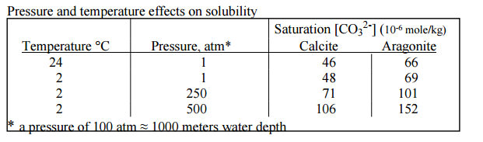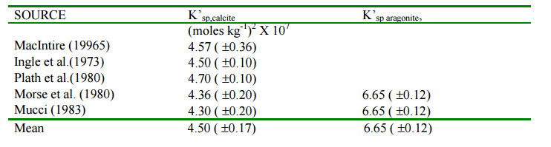

**Temperature Dependence of Ksp’:** CaCO3 is an unusual mineral in that it is more soluble at lower temperatures (K sp’ increases with decreasing temperature); the effect is only about 4% over a temperature range of 20C. Since the temperature range in the deep sea is only a few degrees, this is not important.

**Salinity Dependence of Ksp’:** The apparent solubility product increases about 3% per 1 salinity unit increase. Since salinity changes in the deep sea are typically much less than this, this is insignificant.

**Pressure Dependence of Ksp’:** The effect of pressure is the most important environmental variable affecting the solubility product of CaCO3. K sp’ increases with increasing pressure. Thermodynamically, the pressure effect is related to the partial molar volumes of Ca2+, CO3 2- and CaCO3. Like free energies, the partial molar change for the reaction is calculated from the sum of the products minus the sum of the reactants:



The Vr for calcite is negative meaning that the volume occupied by CaCO3 is greater than the combined volume of Ca2+ and CO3 2- in solution and CaCO3 becomes more soluble with depth. Fred Sayles (1985) from WHOI designed an instrument to recover pore waters from marine sediments in situ. He deployed this instrument in calcite rich sediments at different depths and determined the calcium and carbonate concentrations. If one assumes the pore water environment is at equilibrium with respect to calcite then this is an in situ measurement of Ksp’. The solubility increases by about a factor of 2 for a change of 4 km.

**What makes [CO3 2-] change**? As deep water “ages” during its trip through the Atlantic, Indian, and Pacific Oceans, the degradation of organic matter and dissolution of CaCO3, in a 4:1 ratio, cause seawater to become slightly more acidic, thus lowering in CO3 2- content. The concentration ranges form 110 mol/ kg in the deep North Atlantic (below 2 km) to 70-80 mol/ kg in the North Pacific. A change of about 30 % (Broecker and Peng, 1982).

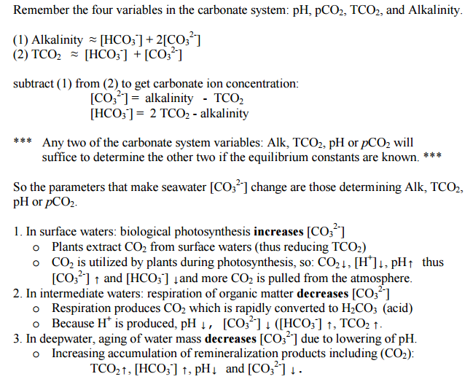

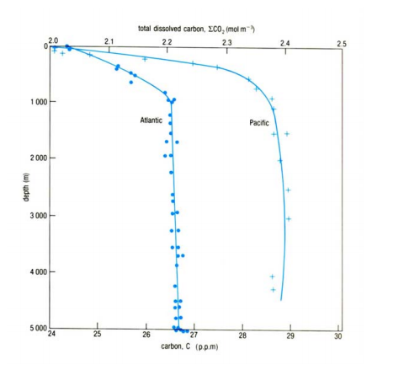

These processes control the spatial variations in the [CO3 2-] of seawater.

If we know how the measured seawater [CO3 2-] varies from place to place, then we can compare the in situ [CO3 2-] saturation to the measured values to determine if calcite will dissolve or not (e.g. the saturation level). The saturation horizon is deepest in the Atlantic Ocean (~4500 m) relative to the Indian Ocean (~3500 m) and shallowest in the Pacific ((<3000 m). Aragonite is more soluble than calcite therefore the saturation depth is shallower than calcite in the Atlantic it is 2 km.

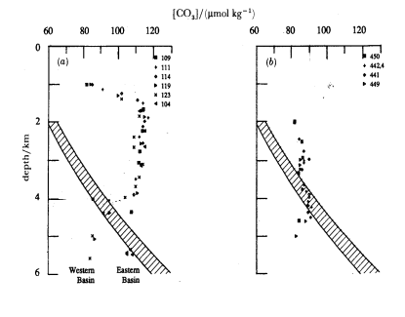

The wide lines in the figure are the predicted carbonate saturation concentration, using the Ksp’ from Sayles (1985) and a Ca concentration of 10.28 x 10-3 mol / kg. The hatched area assumes an error of -+10% in determining the saturation value. Symbols are [CO3 2-] from measurements of Alk and DIC. (a) is in the Atlantic and (b) in the Pacific oceans.

The water depth where calcite dissolution begins to increase markedly as reflected by where the calcite content of the surface sediments begins to decrease abruptly is defined as the lysocline. This depth, like the saturation depth, is different for calcite and aragonite and is different in the different ocean. Note that some dissolution occurs above the saturation depth due to pH lowering as a result of organic matter decomposition within the sediment.

**Silica Preservation in the Ocean**

A fundamental difference between carbonate and silicate sediments is that seawater is everywhere under-saturated with respect to silica (silica secreting organisms have to spend energy to metabolize and produce the shells). The solubility of silica decreases with decreasing temperature by about 30% from 25-5 ºC, with less silica dissolving when the waters are colder. The solubility increases slightly with pressure, providing some offset to the temperature effect. Most of the dissolution occurs at the seabed and only 1- 10% of the flux survives dissolution. Siliceous sediments are therefore found in zones of high productivity and high sedimentation rates but only below the CCD where less carbonate dilution occurs and specifically at high latitudes where the water is colder; in such reasons, diatom productivity is typically high.

Other factors that affect the preservation of shell material are the size and shape of the shells; the smaller and thinner they are the more surface area to volume they have and the faster they dissolve. Sometimes, the assemblage of organisms may change due to differential dissolution (dissolution index, used for reconstruction of lysocline depth and carbonate chemistry). The settling rate of the small particles is expected to be very slow (stocks law); thus, few micron size coccoliths are expected to dissolve while still in the water column. The reason we find them in the sediment is that they take the “elevator” down. Most of the particles arrive to the sea floor as aggregates, which are bio-packaged as fecal pellets and marine snow. The speedy transfer allows burial and preservation.

Reference

Emerson, S. and D. Archer (1990) Calcium carbonate preservation in the ocean, Phil.

Trans. R. Soc. Lond., A 331, 29-40.

Seibold, E. and W. Berger (1982) the Sea Floor, Springer Verlag, N.Y., 288 p.

Morse, J. and F. MacKenzie (1990) Geochemistry of Sedimentary Carbonates, Elsevier, N.Y., 707.

Sayles, F. (1985) The solubility of CaCO3 in seawater at 2C based upon in-situ sampled pore water composition, Mar. Chem., 9, 223-235.